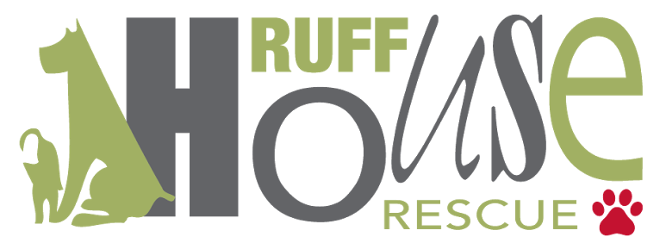
PO Box 365
Oceanside, NY 11572

Foster Checklist

______ Vetting for foster dogs is done through the Rescue. You must contact Ruff House Rescue via email ruffhousefoster@gmail.com to make a vet appointment with a specified Ruff House Rescue veterinarian if you feel the dog needs to see a vet. RUFF HOUSE RESCUE WILL NOT REIMBURSE FOSTERS FOR VACCINATIONS, MEDICINES, SURGERIES, OR OTHER SERVICES PROVIDED BY ANY OTHER VETERINARIAN.

______ If your foster dog has a vet appointment with a Ruff House veterinarian, the foster must call Diane from the office with the Doctor in order for Diane to approve any treatment/meds that the dog needs. 5165236520. We need to know the date and time of your vet appointment, as all vet appointments MUST be approved by Diane. In the event you are at the vet and cannot reach Diane, please text Melissa at 5165899011.

______ Fosters must check in every night via email to ruffhousefoster@gmail.com

______ Fosters are responsible for keeping their schedule of Heartgard and vaccinations. Fosters need to make an appointment via email with the Rescue to pick up Heartgard doses and schedule vaccines.

__________ heartgard date due monthly

__________ dewormer date due

__________ vaccination date due

______ Fosters (not foster-to-adopt) should post updates on the Ruff House Rescue NY Foster Page on Facebook. Outdoor pictures and videos (with the phone held horizontally) are vital to helping your foster(s) get adopted quickly. Please post a complete bio of your foster dog(s). Our volunteers take this information to update our website and Petfinder listings of our dogs as well as use these posts to post on the Ruff House Rescue NY Facebook page and Instagram account.

_________In an emergency only, please call or text our emergency number: Diane 516-523-6520 (if you cannot reach her: Melissa 5165899011)

Keeping your Pet Healthy and Safe:
- Foster dogs must keep their Ruff House Rescue ID tag and martingale collar on at all times. Collars may not be changed.
- Foster dogs must be crated when no one is home or able to supervise,
- Foster dogs should never be left unattended in the yard, or be taken to dog parks or on playdates without prior approval from the Rescue.
- Please do not give treats, toys, or food without approval from the rescue. We recommend training treats made in the US (liver treats), baby carrots, Trader Joe’s cookies, antler, hollow marrow bones.
- If you have another dog, do not give toys or treats this can cause fights.
- NEVER GIVE: Greenies, Rawhides, bullies sticks, Pup’eroni, etc. These treats can cause illness thereby needing a vet visit which the Rescue will not cover.

Date: __________________ Foster Dog’s Name: ________________________

Foster Parent: ____________________________ RHR Representative: ________________________

